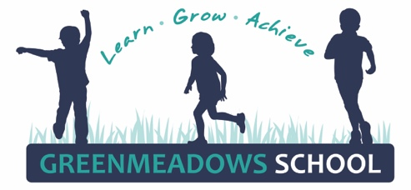
McCAIN RIPPA RUGBY & NETBALL GALA DAY

Wednesday 4th March 2026

BACK FOR 2026!!!!!! THE McCAIN BOYS NETBALL AND GIRLS RIPPA RUGBY GALA DAY!!!!!!

McCain, Hawkes Bay Netball and Hawke’s Bay Rugby are excited to be again hosting the Junior Gala day on Friday 27th March, 9:30am – 2pm at the Mitre 10 Sports Park.

This tournament encourages kids to have a go and try something different, where Year 5/6 boys all play netball against other all boys teams, and Year 3/4 and 5/6 girls all play rippa rugby against other all girls teams.

We encourage as many keen children as possible to come along and have some fun – apart from the actual games there is music, goodies and spot prizes, special guests attending and food trucks and coffee carts available. This will be a fantastic day out – and a great chance for boys and girls to participate in a sport that they perhaps haven’t tried before

Registrations for the day are all made online via Kindo. This can be accessed from our Greenmeadows School website, www.gms.school.nz, just follow the links under the sports tab. Registrations close on Sunday 15th March. THERE IS NO COST TO ENTER.

All teams will need support from at least one parent to coach/manage them throughout the day. No experience needed – you will just need to get your team on the right court/field for each game, rotate any subs and encourage them in the right direction! HB Netball and HB Rugby are intending to supply umpires/refs for the games, however we may be asked to assist if need be. This can also be coordinated with the opposing teams coach/manager. We also need help with transport to and from the Sports Park (departing GMS 8:45am, arriving back approx. 2:30pm).

Parents we need your help! Without this support for coaching/managing/transport we cannot enter our teams – please indicate on your registration if you can help out at all on the day.

Girls Rippa Rugby is played 7 aside, with all gear supplied. Uniform is the GMS Sports Shirt (supplied by the school) and players wear their own navy shorts/skort with bare feet. MOUTHGUARDS ARE COMPULSORY - players must supply their own.

Boys netball is played in the traditional 7 aside format, with all gear supplied. Uniform is the GMS Sports Shirt (supplied by the school) and players wear their own navy shorts with ankle sports socks and appropriate sports shoes for the outdoor surface.

All participants should bring a water bottle, appropriate clothing/sunhat for the weather, lunch, lots of snacks for energy and a great big smile.

We look forward to a fantastic day out with many GMS teams. Register now and come and have a go!!!!!!!!!!!!!!!!!!!

Kind Regards
Nicki Sunley
GMS Sports Co-ordinator
nickis@gms.school.nz

