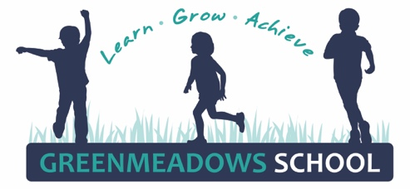
HB PRIMARY SCHOOLS RUGBY
BAREFOOT SEVENS TOURNAMENT
Monday 5th May

Dear Parents/Caregivers and Pupils

The annual Barefoot 7’s Rugby Tournament for HB Primary schools is set for Thursday 23rd May at Hastings Boys High School and Akina Park. This is a fun tournament of tackle rugby for boys and girls with teams graded based on weight, rather than age.

GMS will enter as many teams as possible with players from Years 3 to 6 – just fill in the form below and return it to the sports box in the school office by Friday 10th May. NO LATE ENTRIES PLEASE!!!!!!!

This is full contact rugby involving scrums and tackling, so for safety we do ask that participants have some experience with this format of the game. Mouthguards are essential and players in all grades must be prepared for contact.

There is no cost to attend – but parents we do need your help to transport players and to coach/manage our teams. It’s fun and it’s easy!! Refs are provided for all games, so your role is simply to ensure your team is on the right field at the right time, to rotate any subs and encourage them on. Please indicate the help you can give on your child’s form below – we cannot send teams along without your support. Games commence at 11:00am, so we will be leaving school at 9:30am, returning at 2:45pm. Playing uniform is the GMS sports shirt (issued by the school), navy shorts, and rather obviously – bare feet.

Children are placed into teams that are graded based on weight. Please ensure you enter your child’s weight accurately below – this ensures all teams will play in a fair division. The day is all about fun – participation and enjoyment is the key.

For any further information or enquiries, please contact Nicki at the email address below. We look forward to a fantastic day out with several teams entered from GMS.

Regards
Nicki Sunley, GMS Sports Co-ordinator, nickis@gms.school.nz
……………………………………………………………………………………………………………..………………………………………………………………………
HB Primary Schools Barefoot Sevens Tournament – Registration Form (due Friday 10th May)

Name: _______________________________________________ Room: ____________ Year: __________ has permission to play in the Barefoot Sevens Tournament.

His/her accurate weight is __________ kgs.

I am able to help transport ______ number of children to and from the event (with full licence and current wof/reg).

I am able to help coach/manage a team on the day YES / NO (please circle one).

Signed: ________________________________ Contact Name: _________________________________________

Mobile: ________________________________ Contact Email: _________________________________________

